**Final Report**

1. **INTRODUCTION**
   1. **Project Overview**

Health AI is a generative AI-based virtual healthcare assistant that helps users identify potential diseases based on symptoms, receive natural home remedies, and interact with an AI-powered doctor-style chatbot. Built using the IBM Granite language model, this project focuses on providing instant, intelligent, and accessible medical advice via a user-friendly web interface.

The system is designed with inclusivity and ease-of-use in mind—supporting voice input, a floating chatbot, and image upload (prototype), all through an intuitive Gradio interface deployed on Google Colab.

**1.2 Purpose**

The purpose of Health AI is to provide accessible, intelligent, and immediate healthcare support using generative AI. It empowers users to self-check symptoms, receive natural home remedies, and ask health-related questions via an AI chatbot—without needing to visit a clinic or browse unreliable sources.

This project especially targets:

* Users in remote or under-resourced areas with limited access to medical professionals
* Anyone seeking instant health advice for common symptoms
* Those who prefer natural remedies and early self-care tools

By combining powerful AI (IBM Granite) with a simple Gradio interface, Health AI bridges the gap between basic healthcare needs and emerging technology—making digital health support free, fast, and user-friendly**.**

**2.IDEATION PHASE**

2.1 Problem Statement

2.2 Empathy Map Canvas

2.3 Brainstorming

**3. REQUIREMENT ANALYSIS**

3.1 Customer Journey map

3.2 Solution Requirement

3.3 Data Flow Diagram

3.4 Technology Stack

**4. PROJECT DESIGN**

4.1 Problem Solution Fit

4.2 Proposed Solution

4.3 Solution Architecture

**5. PROJECT PLANNING & SCHEDULING**

5.1 Project Planning

**6. FUNCTIONAL AND PERFORMANCE TESTING**

6.1 Performance Testing

**7. RESULTS**

**7.1 Output Screenshots**

### **Sign up/login page:**

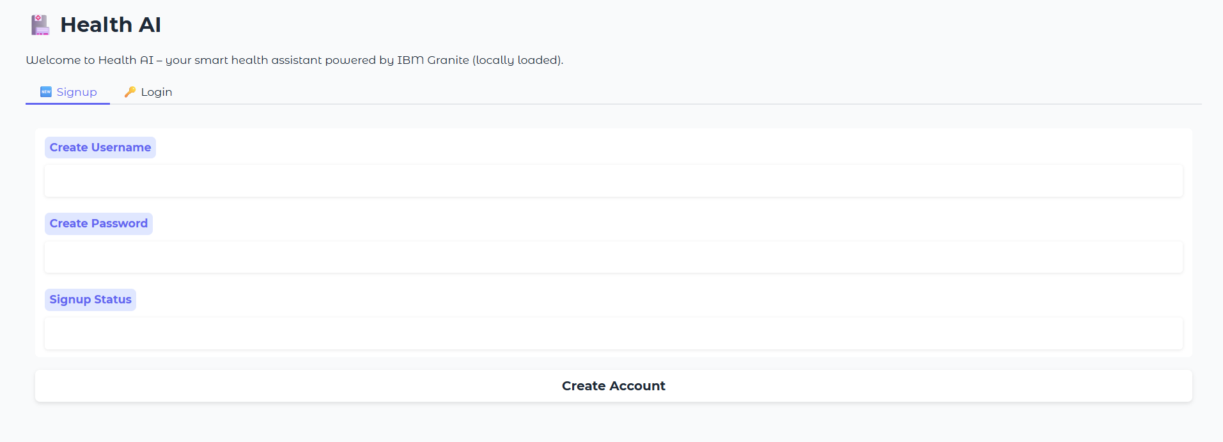

### 

**Description:** The Signup and Login page of Health AI provides a secure and personalized entry point for users. New users can easily create an account by entering a unique username and password, while returning users can log in to access their dashboard. This authentication system ensures that only verified users can use key features like symptom identification, home remedies, and the AI chatbot. After a successful login, the interface dynamically updates to hide the signup and login sections, showing the full set of tools available. This approach enhances both security and user experience, creating a professional, app-like flow.

### **Symptom Identifier Page:**

### 

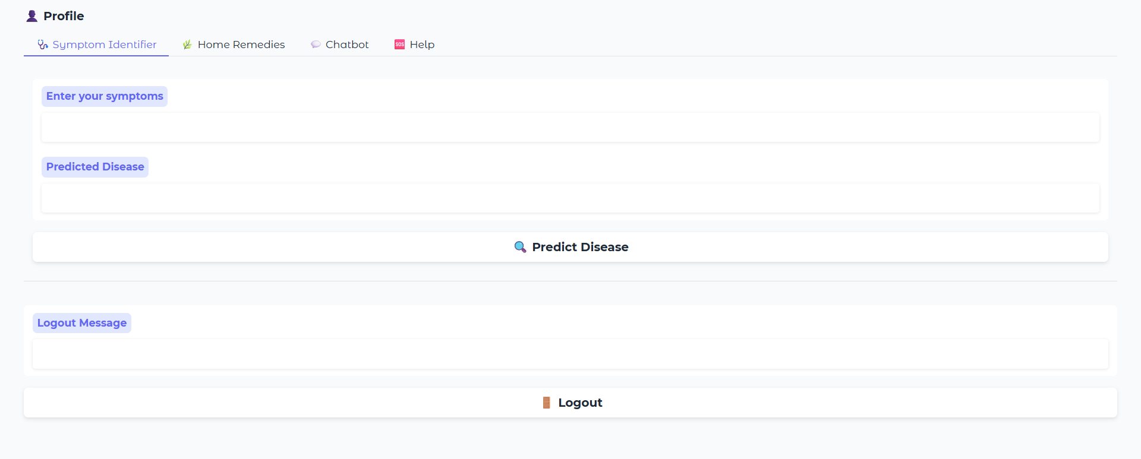

**Description:** The **Symptom Identifier** is a key feature of Health AI that helps users understand possible health conditions based on the symptoms they experience. By simply entering symptoms like *fever*, *headache*, or *fatigue*, the system uses a powerful AI model to predict the most likely disease or condition. This tool acts as an intelligent first step before seeking medical advice, offering quick insights within seconds. It's designed to be user-friendly, accurate, and accessible to everyone. While not a replacement for a doctor, it provides helpful information that can guide users toward better health awareness.

**Symptom Identifier Output:**

### 

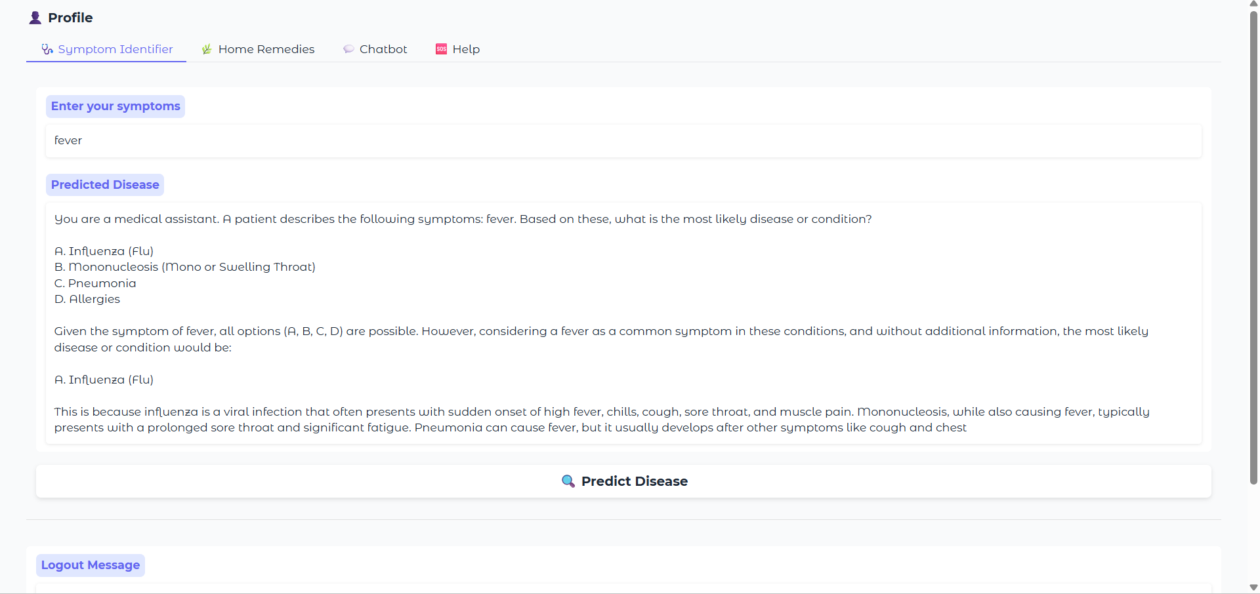

### 

### **Home Remedies Page:**

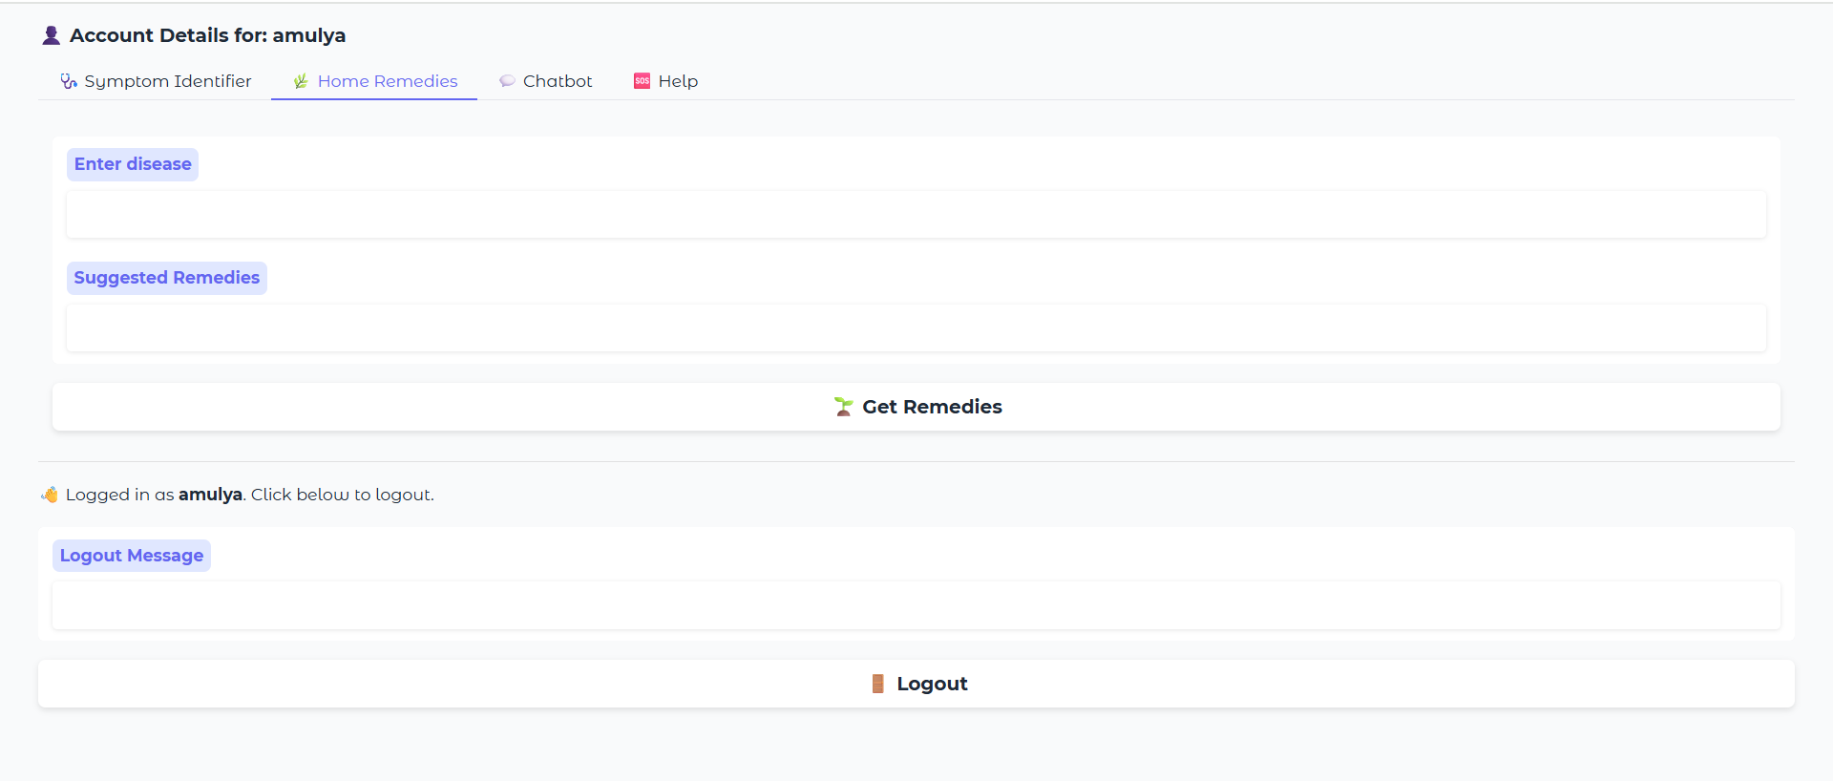

**Description:** The **Home Remedies** feature of Health AI provides natural and practical solutions for common health issues. Users can enter the name of a condition—such as *cold*, *headache*, or *indigestion*—and the AI will suggest trusted, home-based remedies. These remedies are generated using a medical language model and focus on ingredients or practices that are easily available and safe. This tool is especially useful for those looking for gentle, non-pharmaceutical relief. It encourages self-care while supporting traditional wellness practices in a modern, AI-powered way.

**Home Remedies output:**

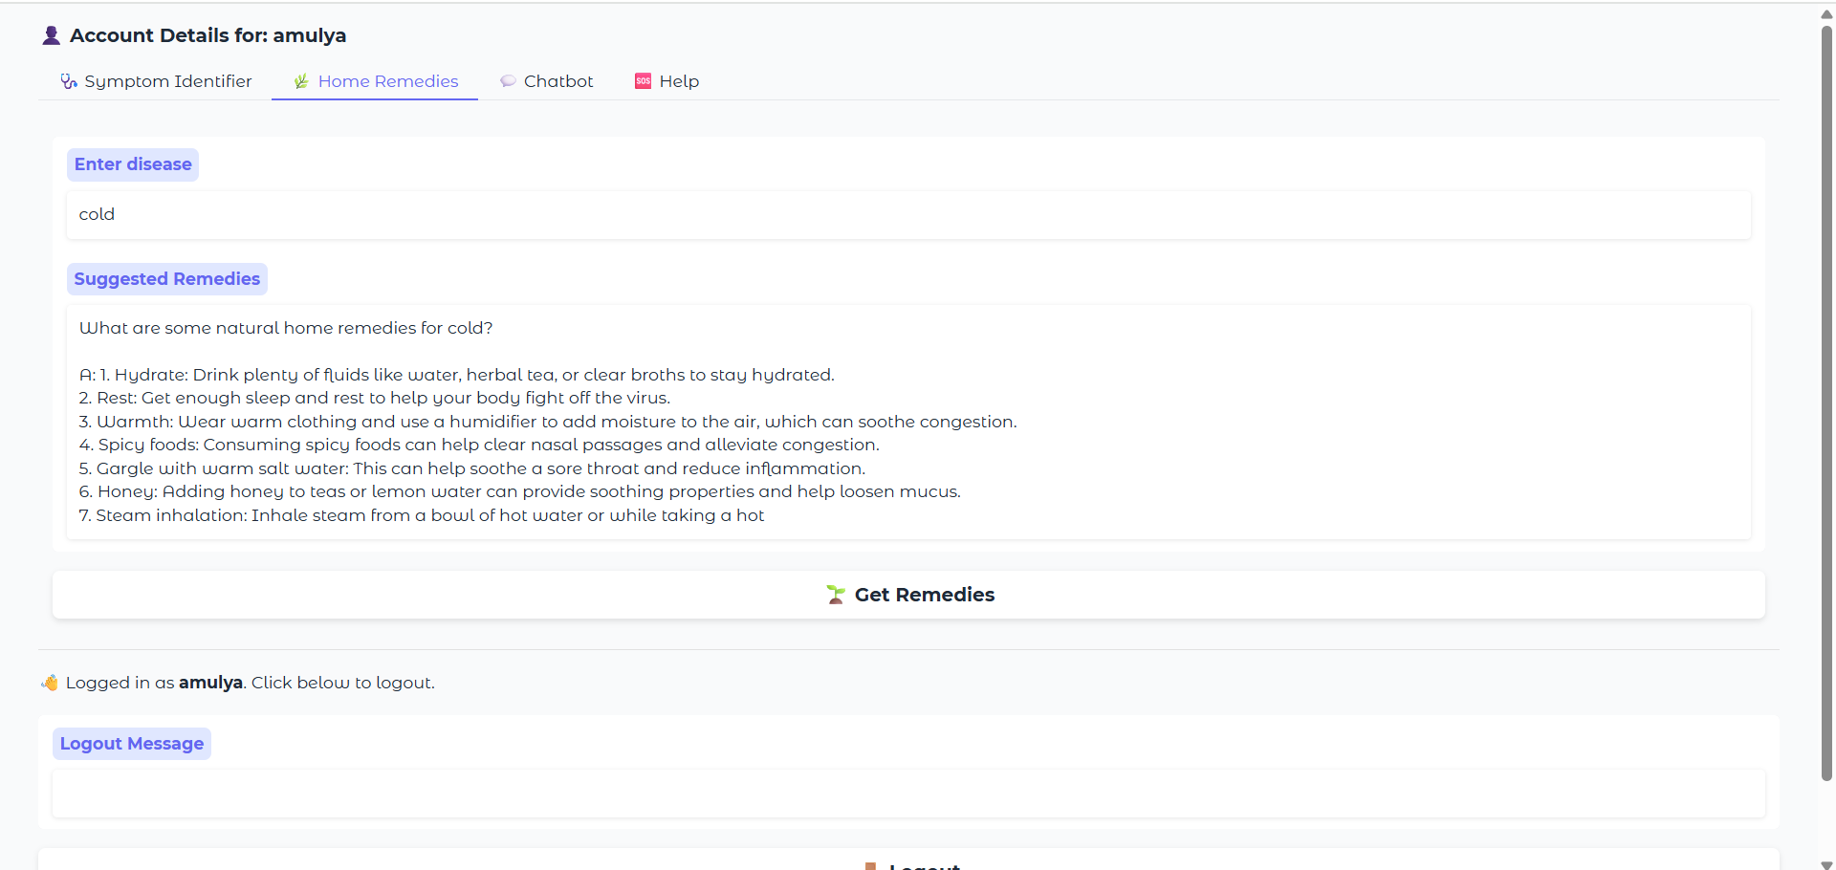

**Patient chat page:**

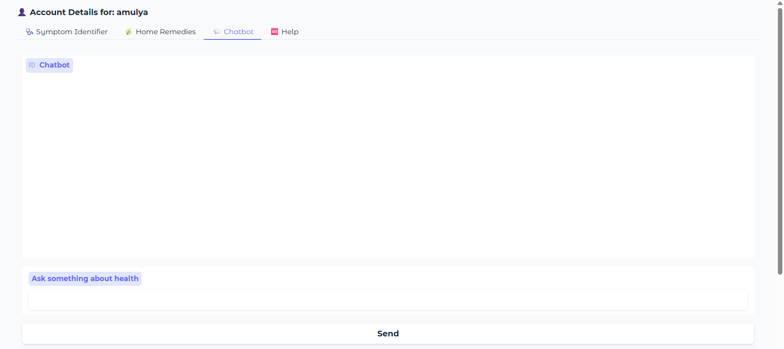

**Description:**The HealthBot Chat Assistant is an intelligent, conversational feature of Health AI designed to answer a wide range of health-related questions. Users can chat with the AI in natural language, asking about symptoms, remedies, healthy habits, or general medical advice. Powered by the IBM Granite AI model, the chatbot responds instantly with clear, informative answers, creating a helpful and engaging user experience. It’s like having a virtual health assistant available anytime. While it doesn’t replace professional medical consultation, it offers quick support and guidance for everyday health concerns.

**Patient chat output:**

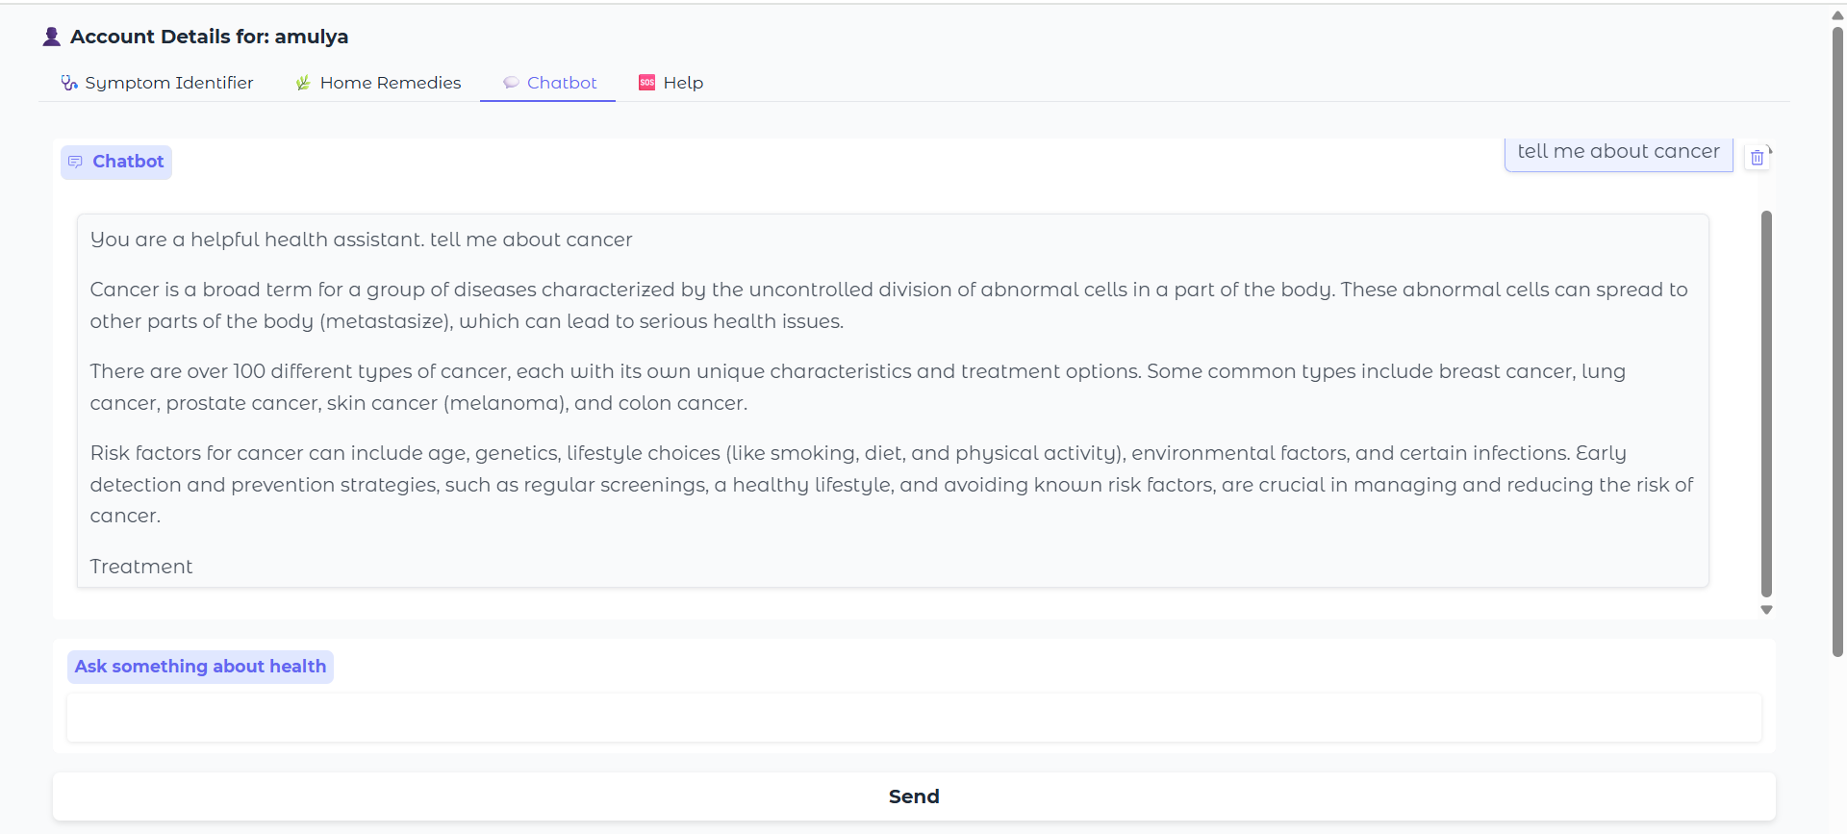

**Help page:**

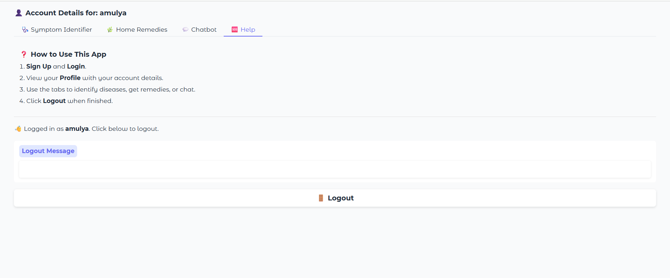

**Description:**The Help section of Health AI serves as a quick and easy guide for users to understand how to use the application effectively. It provides clear instructions on signing up, logging in, using the symptom identifier, exploring home remedies, and chatting with the HealthBot. This section ensures that even first-time users can navigate the platform with confidence. Designed to be simple and informative, the Help tab enhances user experience by answering common questions and explaining each feature’s purpose. It acts as a built-in support system, available whenever users need guidance.

**8. ADVANTAGES & DISADVANTAGES**

Health AI offers several significant advantages that make it a powerful and accessible healthcare assistant. It provides instant, AI-generated responses to user inputs such as symptoms and disease names, helping users receive quick guidance without needing to visit a doctor. The application supports natural language interaction and voice input, making it user-friendly for all age groups. Its browser-based deployment using Gradio and Google Colab ensures that it runs without any installation, making it easily accessible on any device. Moreover, the multi-functional design—combining a symptom identifier, home remedy generator, and AI chatbot—adds convenience and value for the user.

However, there are some limitations to consider. The AI's medical accuracy is not guaranteed, as it is based on a language model and does not connect to verified clinical databases. It cannot replace professional medical diagnosis, especially in serious or emergency conditions. The system currently lacks persistent storage, meaning user data and chat history are lost once the Colab session ends. Additionally, since the app runs online, it depends on a stable internet connection. Despite these challenges, Health AI sets a strong foundation for expanding digital healthcare tools and improving accessibility in the future.

**9. CONCLUSION**

The HealthAI project effectively demonstrates the potential of AI in revolutionizing healthcare assistance. By integrating IBM's Granite language model, the platform enables users to receive personalized health insights through Patient Chat, Disease Prediction, Treatment Plan Generation, and Health Analytics, making healthcare information more accessible.

Utilizing IBM Watson Machine Learning, the application ensures accurate health question answering, detailed disease prediction, personalized treatment recommendations, and insightful health trend analysis. The structured development process—spanning model selection, core feature implementation, backend and frontend development, and deployment—led to the creation of an interactive, user-friendly platform.

Built with Streamlit, HealthAI facilitates seamless visualization of health data and AI-generated insights, ensuring an efficient and responsive experience. This project highlights how targeted AI models and a well-structured framework can enhance healthcare accessibility. With future scalability in mind, HealthAI has the potential to expand its capabilities, incorporating more advanced diagnostics and broader medical applications.

**10. FUTURE SCOPE**

Health AI has vast potential for future development and real-world impact. One major enhancement would be integrating a secure backend with user authentication, allowing users to save their health history, previous queries, and chatbot conversations. The system can also be expanded to include multilingual support, making it accessible to users in regional languages across India and globally. Another promising direction is the addition of image-based disease detection using deep learning (CNN models), where users can upload skin rashes, wounds, or X-rays for preliminary analysis. Integrating live medical databases such as WHO or local hospital records could improve the accuracy of symptom prediction and remedy suggestions. Moreover, the chatbot could evolve into a hybrid system that combines generative AI with real-time doctor consultation APIs, allowing users to escalate critical queries to licensed professionals. Finally, deploying the application on platforms like Hugging Face Spaces or Streamlit Cloud would make it permanently accessible and scalable to larger user bases.

**11. APPENDIX**

**GitHub Link:** https://github.com/Amulyadande8/Health-AI-Project